**UID ASSIGNMENT 4**

**Comparison of Familiar vs. Unfamiliar User Interface Design**

**SHERYL KATRINA M**

**230701310**

**Home Screen Overview :**

The home screen serves as the landing page for users to explore different Apple products. It includes a navigation bar at the top with categories like iPad, Mac, iPhone, and Support. Additionally, there is a large promotional section introducing the iPhone, with an emphasis on user engagement through a call-to-action button labeled "Explore."

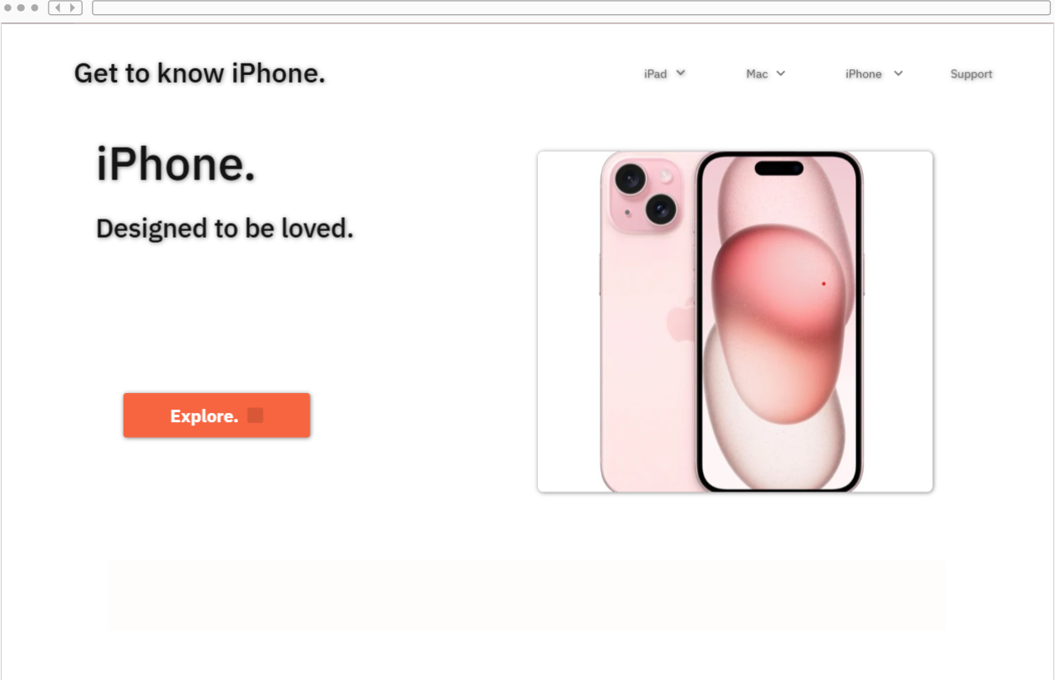

**Familiar User Interface Elements in Home Screen**

1. Navigation Without Drop-Down Menus:
   * A more familiar approach would be displaying all navigation options directly on the navigation bar without requiring users to hover or click to reveal them.
   * Reasoning: Websites that display their main menu items upfront reduce the chance of users missing key sections, ensuring easier navigation for both new and experienced users.
2. Explore Button Functionality:
   * The "Explore." button is designed as a primary call-to-action.
   * However, there is no immediate indication of what the user will explore upon clicking.
   * Reasoning: If a user is unfamiliar with the interface, they might expect a product catalog or more information about iPhones rather than being redirected to a different screen.

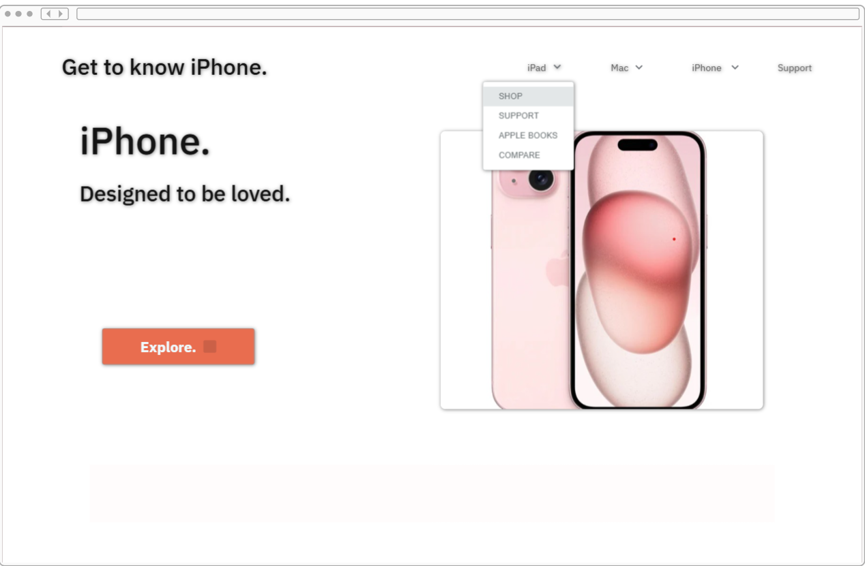

**Unfamiliar User Interface Elements in Home Screen**

1. **Drop-Down Menu Behavior:**
   * The navigation bar includes a **drop-down menu** under certain categories (e.g., "iPad"). While drop-down menus are common in web navigation, their implementation can sometimes confuse users unfamiliar with hidden options.
   * The menu appears only when hovered over or clicked, potentially causing users unfamiliar with this interaction style to miss available choices (Shop, Support, Apple Books, Compare).
   * **Reasoning:** Many websites feature visible navigation links rather than hidden options under a drop-down. Users who do not recognize this interaction pattern might struggle to find what they need.

**Explore Screen Overview :**

The Explore screen features an extensive product showcase, highlighting the **Apple Pencil, iPhone, MacBook, iMac, and iPad.** There are bold promotional banners, a **search bar, and product categories** arranged visually for easy access.

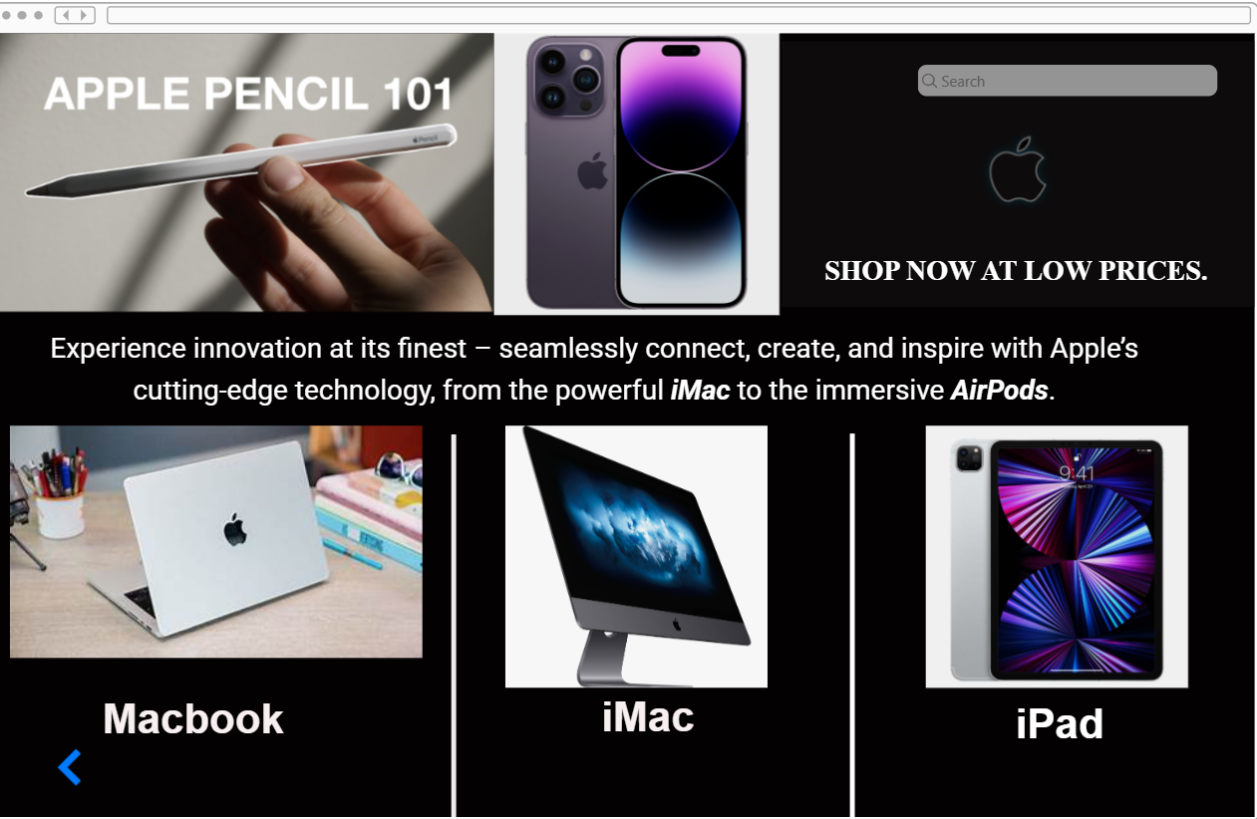

**Unfamiliar User Interface Elements in Explore Screen**

1. **Lack of Navigation Feedback:**
   * After clicking "Explore," users land on a different screen, but there is **no clear navigation indicator** guiding them back.
   * **Reasoning:** Many websites include breadcrumbs or a visible back button to help users navigate, but this page does not.
2. **Search Bar Placement & Visibility:**
   * The search bar is positioned near the top right but **blends into the dark background** rather than standing out.
   * **Reasoning:** Users accustomed to prominent search bars might not easily recognize or use it efficiently.
3. **Inconsistent Product Categories Presentation:**
   * The screen presents products in different styles: Apple Pencil and iPhone are highlighted with large banners, while MacBook, iMac, and iPad appear in a grid layout.
   * **Reasoning:** This inconsistency can cause confusion for users expecting uniform navigation between sections.

**Familiar User Interface Elements in Explore Screen**

1. **Clearer Navigation Options:**
   * Familiar designs include visible navigation breadcrumbs or an easily accessible back button.
   * **Reasoning:** These elements help users understand their location within the website and navigate smoothly.
2. **Consistent Product Display Layout:**
   * A familiar approach would ensure that all product categories appear in a uniform grid layout, avoiding unnecessary emphasis on certain products.
   * **Reasoning:** A uniform layout improves visual clarity and helps users find products easily without confusion.